**LAPORAN**

**PRAKTIKUM ANALISIS ALGORITMA**

**TUGAS 05**



**Disusun Oleh:**

Risyad Pangestu (140810170003)

Dimas Satria Prakoso (140810170007)

Syaina Nur Fauziyah (140810170025)

Imron Madani (140810170061)

**PROGRAM STUDI TEKNIK INFORMATIKA**

**FAKULTAS MATEMATIKA DAN ILMU PENGETAHUAN ALAM**

**UNIVERSITAS PADJADJARAN**

**SUMEDANG**

**2019**

**LAPORAN**

**PRAKTIKUM ANALISIS ALGORITMA**

**TUGAS 05**

1. Dengan menggunakan undirected graph dan adjacency matrix berikut, buatlah koding programmnyamenggunakan bahasa C++

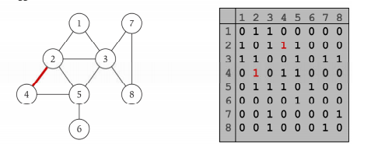

**Program:**

/*

* C++ Program to Implement Adjacency Matrix

*/

#include <iostream>

#include <cstdlib>

usingnamespace std;

#define MAX 20

/*

* Adjacency Matrix Class

*/

classAdjacencyMatrix

{

private:

int n;

int **adj;

bool *visited;

public:

AdjacencyMatrix(int n)

{

this->n = n;

visited = newbool [n];

adj = newint* [n];

for (inti = 0; i< n; i++)

{

adj[i] = newint [n];

for(int j = 0; j < n; j++)

{

adj[i][j] = 0;

}

}

}

/*

* Adding Edge to Graph

*/

voidadd_edge(int origin, intdestin)

{

if( origin> n || destin> n || origin <0 || destin<0)

{

cout<<"Invalid edge!\n";

}

else

{

adj[origin - 1][destin - 1] = 1;

}

}

/*

* Print the graph

*/

voiddisplay()

{

inti,j;

for(i = 0;i <n;i++)

{

for(j = 0; j < n; j++)

cout<<adj[i][j]<<" ";

cout<<endl;

}

}

};

/*

* Main

*/

intmain()

{

int nodes, max_edges, origin, destin;

cout<<"Enter number of nodes: ";

cin>>nodes;

AdjacencyMatrix am(nodes);

max_edges = nodes * (nodes - 1);

for (inti = 0; i<max_edges; i++)

{

cout<<"Enter edge (-1 -1 to exit): ";

cin>>origin>>destin;

if((origin == -1) && (destin == -1))

break;

am.add_edge(origin, destin);

}

am.display();

return0;

}

**Output:**

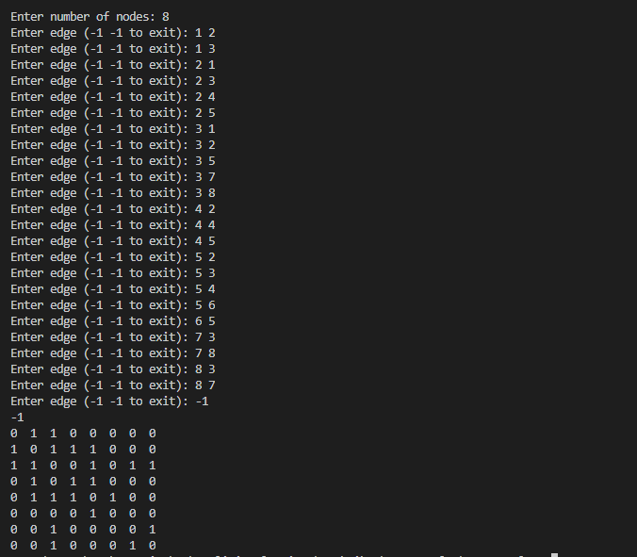

1. Dengan menggunakan undirected graph dan representasi adjacency list, buatlah koding programmnya menggunakan bahasa C++.

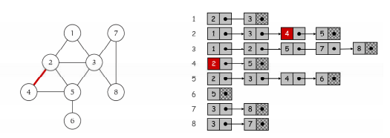

**Program:**

/*

* C++ Program to Implement Adjacency List

*/

#include <iostream>

#include <cstdlib>

using namespace std;

/*

* Adjacency List Node

*/

struct AdjListNode

{

int dest;

struct AdjListNode* next;

};

/*

* Adjacency List

*/

struct AdjList

{

struct AdjListNode *head;

};

/*

* Class Graph

*/

class Graph

{

private:

int V;

struct AdjList* array;

public:

Graph(int V)

{

this->V = V;

array = new AdjList [V];

for (int i = 0; i < V; ++i)

array[i].head = NULL;

}

/*

* Creating New Adjacency List Node

*/

AdjListNode* newAdjListNode(int dest)

{

AdjListNode* newNode = new AdjListNode;

newNode->dest = dest;

newNode->next = NULL;

return newNode;

}

/*

* Adding Edge to Graph

*/

void addEdge(int src, int dest)

{

AdjListNode* newNode = newAdjListNode(dest);

newNode->next = array[src].head;

array[src].head = newNode;

newNode = newAdjListNode(src);

newNode->next = array[dest].head;

array[dest].head = newNode;

}

/*

* Print the graph

*/

void printGraph()

{

int v;

for (v = 1; v <= V; ++v)

{

AdjListNode* pCrawl = array[v].head;

cout<<"\n Adjacency list of vertex "<<v<<"\n head ";

while (pCrawl)

{

cout<<"-> "<<pCrawl->dest;

pCrawl = pCrawl->next;

}

cout<<endl;

}

}

};

/*

* Main

*/

int main()

{

Graph gh(8);

gh.addEdge(1, 2);

gh.addEdge(1, 3);

gh.addEdge(2, 4);

gh.addEdge(2, 5);

gh.addEdge(2, 3);

gh.addEdge(3, 7);

gh.addEdge(3, 8);

gh.addEdge(4, 5);

gh.addEdge(5, 3);

gh.addEdge(5, 6);

gh.addEdge(7, 8);

// print the adjacency list representation of the above graph

gh.printGraph();

return 0;

}

**Output:**

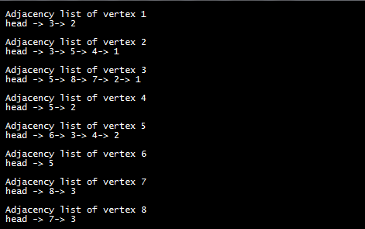

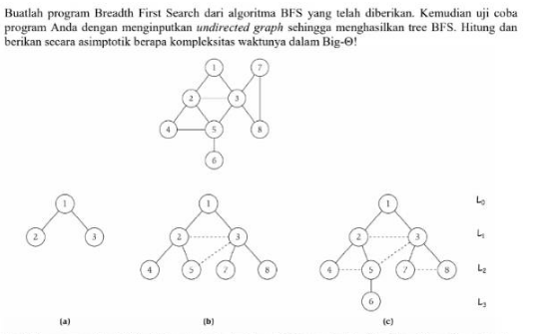

(a)

|  |
| --- |
| // Program to print BFS traversal from a given  // source vertex. BFS(int s) traverses vertices  // reachable from s.  #include<iostream>  #include <list>  using namespace std;  // This class represents a directed graph using  // adjacency list representation  class Graph  {  int V; // No. of vertices  // Pointer to an array containing adjacency  // lists  list<int> *adj;  public:  Graph(int V); // Constructor  // function to add an edge to graph  void addEdge(int v, int w);  // prints BFS traversal from a given source s  void BFS(int s);  };  Graph::Graph(int V)  {  this->V = V;  adj = new list<int>[V];  }  void Graph::addEdge(int v, int w)  {  adj[v].push_back(w); // Add w to v’s list.  }  void Graph::BFS(int s)  {  // Mark all the vertices as not visited  bool *visited = new bool[V];  for(int i = 0; i< V; i++)  visited[i] = false;  // Create a queue for BFS  list<int> queue;  // Mark the current node as visited and enqueue it  visited[s] = true;  queue.push_back(s);  // 'i' will be used to get all adjacent  // vertices of a vertex  list<int>::iterator i;  while(!queue.empty())  {  // Dequeue a vertex from queue and print it  s = queue.front();  cout<< s << " ";  queue.pop_front();  // Get all adjacent vertices of the dequeued  // vertex s. If a adjacent has not been visited,  // then mark it visited and enqueue it  for (i = adj[s].begin(); i != adj[s].end(); ++i)  {  if (!visited[*i])  {  visited[*i] = true;  queue.push_back(*i);  }  }  }  }  // Driver program to test methods of graph class  int main()  {  // Create a graph given in the above diagram  Graph g(3);  g.addEdge(1,2);  g.addEdge(1,3);  cout<< "Following is Breadth First Traversal "  << "(starting from vertex 2) \n"  << "soal (a) : ";  g.BFS(1);  return 0;  } |

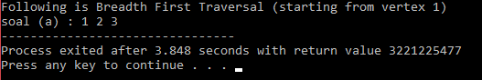

(b)

|  |
| --- |
| // Program to print BFS traversal from a given  // source vertex. BFS(int s) traverses vertices  // reachable from s.  #include<iostream>  #include <list>  using namespace std;  // This class represents a directed graph using  // adjacency list representation  class Graph  {  int V; // No. of vertices  // Pointer to an array containing adjacency  // lists  list<int> *adj;  public:  Graph(int V); // Constructor  // function to add an edge to graph  void addEdge(int v, int w);  // prints BFS traversal from a given source s  void BFS(int s);  };  Graph::Graph(int V)  {  this->V = V;  adj = new list<int>[V];  }  void Graph::addEdge(int v, int w)  {  adj[v].push_back(w); // Add w to v’s list.  }  void Graph::BFS(int s)  {  // Mark all the vertices as not visited  bool *visited = new bool[V];  for(int i = 0; i< V; i++)  visited[i] = false;  // Create a queue for BFS  list<int> queue;  // Mark the current node as visited and enqueue it  visited[s] = true;  queue.push_back(s);  // 'i' will be used to get all adjacent  // vertices of a vertex  list<int>::iterator i;  while(!queue.empty())  {  // Dequeue a vertex from queue and print it  s = queue.front();  cout<< s << " ";  queue.pop_front();  // Get all adjacent vertices of the dequeued  // vertex s. If a adjacent has not been visited,  // then mark it visited and enqueue it  for (i = adj[s].begin(); i != adj[s].end(); ++i)  {  if (!visited[*i])  {  visited[*i] = true;  queue.push_back(*i);  }  }  }  }  // Driver program to test methods of graph class  int main()  {  // Create a graph given in the above diagram  Graph f(8);  f.addEdge(1,2);  f.addEdge(1,3);  f.addEdge(2,3);  f.addEdge(2,4);  f.addEdge(2,5);  f.addEdge(3,5);  f.addEdge(3,7);  f.addEdge(3,8);  cout<< "Following is Breadth First Traversal "  << "(starting from vertex 2) \n"  << "soal (b) : ";  f.BFS(1);  return 0;  } |

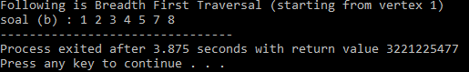

(c)

|  |
| --- |
| // Program to print BFS traversal from a given  // source vertex. BFS(int s) traverses vertices  // reachable from s.  #include<iostream>  #include <list>  using namespace std;  // This class represents a directed graph using  // adjacency list representation  class Graph  {  int V; // No. of vertices  // Pointer to an array containing adjacency  // lists  list<int> *adj;  public:  Graph(int V); // Constructor  // function to add an edge to graph  void addEdge(int v, int w);  // prints BFS traversal from a given source s  void BFS(int s);  };  Graph::Graph(int V)  {  this->V = V;  adj = new list<int>[V];  }  void Graph::addEdge(int v, int w)  {  adj[v].push_back(w); // Add w to v’s list.  }  void Graph::BFS(int s)  {  // Mark all the vertices as not visited  bool *visited = new bool[V];  for(int i = 0; i< V; i++)  visited[i] = false;  // Create a queue for BFS  list<int> queue;  // Mark the current node as visited and enqueue it  visited[s] = true;  queue.push_back(s);  // 'i' will be used to get all adjacent  // vertices of a vertex  list<int>::iterator i;  while(!queue.empty())  {  // Dequeue a vertex from queue and print it  s = queue.front();  cout<< s << " ";  queue.pop_front();  // Get all adjacent vertices of the dequeued  // vertex s. If a adjacent has not been visited,  // then mark it visited and enqueue it  for (i = adj[s].begin(); i != adj[s].end(); ++i)  {  if (!visited[*i])  {  visited[*i] = true;  queue.push_back(*i);  }  }  }  }  // Driver program to test methods of graph class  int main()  {  // Create a graph given in the above diagram  Graph e(8);  e.addEdge(1,2);  e.addEdge(1,3);  e.addEdge(2,3);  e.addEdge(2,4);  e.addEdge(2,5);  e.addEdge(3,7);  e.addEdge(3,8);  e.addEdge(4,5);  e.addEdge(5,6);  e.addEdge(7,8);  cout<< "Following is Breadth First Traversal "  << "(starting from vertex 2) \n"  << "soal (c) : ";  e.BFS(1);  return 0;  } |

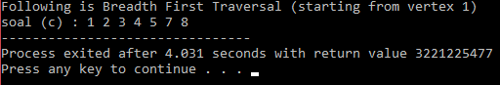

Big O dar ialgoritma BFS O(N) dengan N=V+E dimana V=jumlahVertex ,E=jumlah Edges

1. Buatlah program Depth First Search dari algoritma DFS yang telah diberikan. Kemudian uji coba program Anda dengan menginputkan undirected graph sehingga menghasilkan tree DFS. Hitung dan berikan secara asimptotik berapa kompleksitas waktunya dalam Big-Θ!

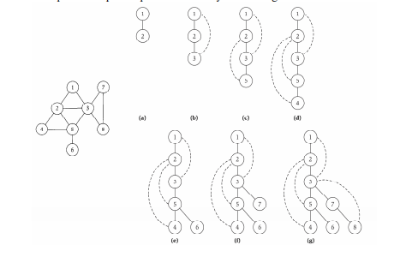

Code

|  |
| --- |
| #include<iostream>  #include<list>  using namespace std;  class Graph  {  int V;  list<int> *adj;  void DFSUtil(int v, bool visited[]);  public:  Graph(int V);  void addEdge(int v, int w);  void DFS(int v);  };  Graph::Graph(int V)  {  this->V = V;  adj = new list<int>[V];  }  void Graph::addEdge(int v, int w)  {  adj[v].push_back(w);  }  void Graph::DFSUtil(int v, bool visited[])  {  visited[v] = true;  cout << v << " ";  list<int>::iterator i;  for (i = adj[v].begin(); i != adj[v].end(); ++i)  if (!visited[*i])  DFSUtil(*i, visited);  }  void Graph::DFS(int v)  {  bool *visited = new bool[V];  for (int i = 0; i < V; i++)  visited[i] = false;  DFSUtil(v, visited);  }  int main()  {  int node,start;  cout<<"Input the amount of your nodes : ";cin>>node;  Graph g(node);  cout<<"Instructions :"<<endl;  cout<<"1. Enter the number of nodes from 0 to n-1"<<endl;  cout<<"2. Enter negative numbers (such as -1) on either node input to to exit the program"<<endl;  for(;;){  int node1,node2;  cout<<"Enter number between "<<0<<" to "<<node-1<<endl;  cout<<"Input node 1 : ";cin>>node1;  cout<<"Input node 2 : ";cin>>node2;  if(node1>=0&&node2>=0&&node1<node&&node2<node){  g.addEdge(node1,node2);  cout<<endl;  }  else if(node1<0||node2<0)  break;  else  cout<<"Wrong input. Please enter again"<<endl;  }  back:  cout<<"\nNode starts from : ";cin>>start;  if(start<0||start>node-1){  cout<<"Wrong input. Please enter again"<<endl;  goto back;  }  cout<<"Your Depth First Traversal (starting from vertex "<<start<<")"<<endl;  g.DFS(start);  return 0;  } |

Hasil Program :

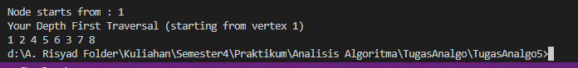

Kompleksitas Big O dari DFS O(bm), karena kita hanya perlu menyimpan satu buah lintasan tunggal dari akar sampai daun, ditambah dengan simpul-simpul saudara kandungnya yang belum dikembangkan.